**Lab 1: Setting up the Web Development Environment**

1. **Install a Code Editor**

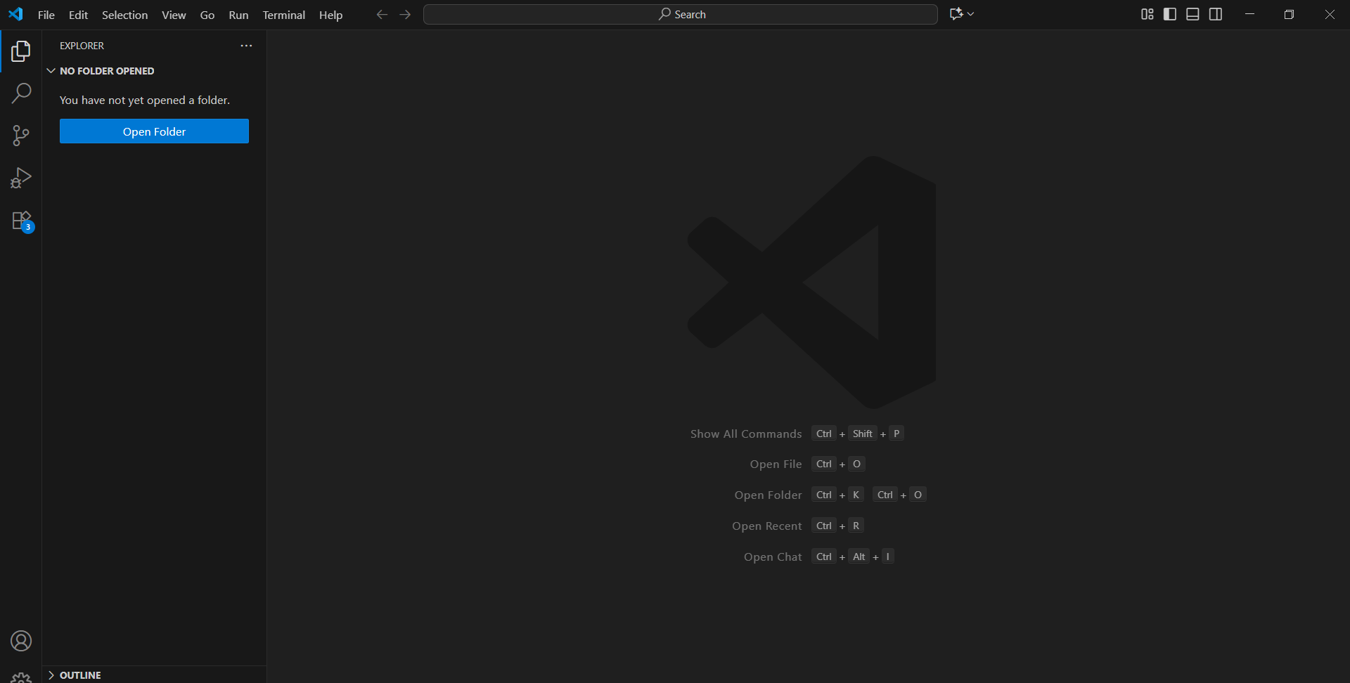

1. **Install Web Browsers**

* I will Prefer Google Chrome

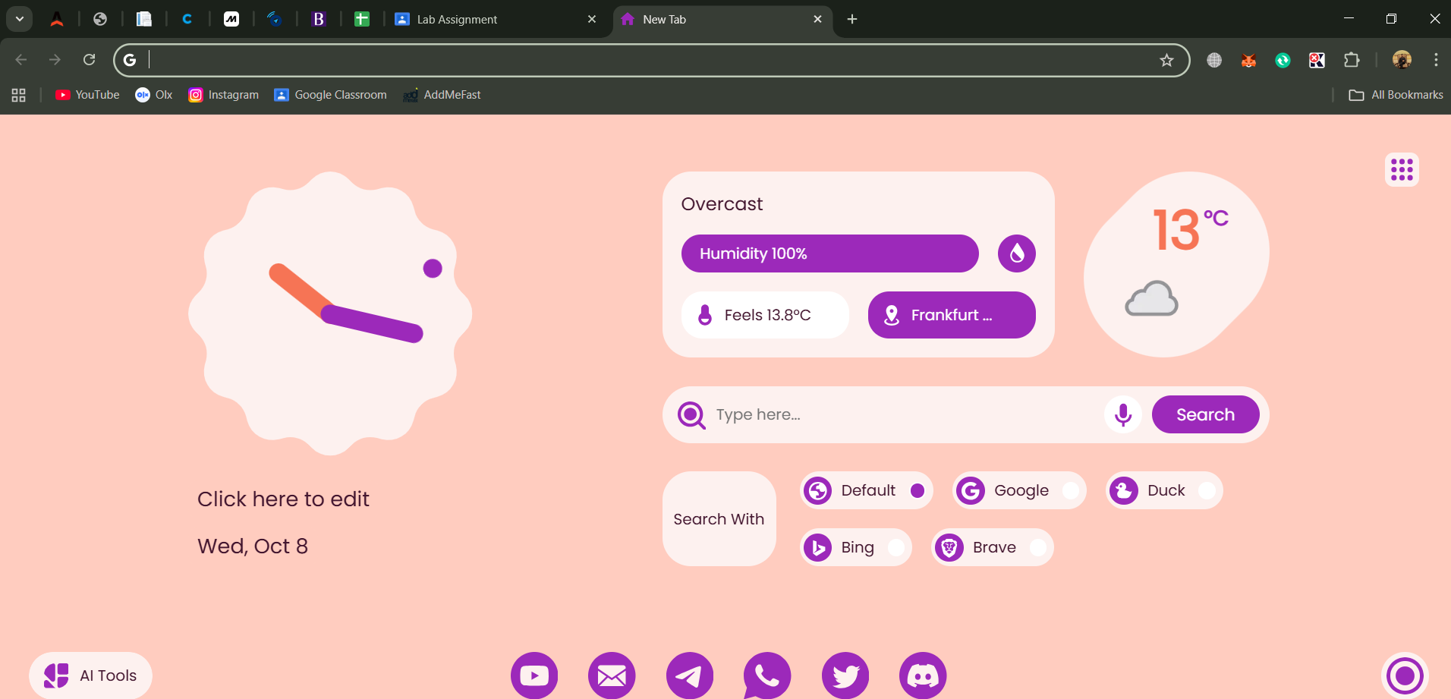

1. Set Up Version Control
   * Install Git
   * Configure Git with your username and email:
   * git config --global user.name "Your Name"
   * git config --global user.email “you@example.com”

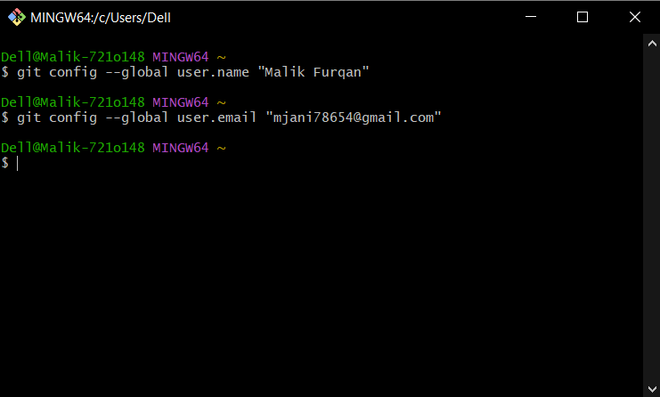

1. **Create a Project Folder**
   * Make a folder named *WebDevLab1* on your desktop or preferred location
   * Inside, create subfolders: *html, css, js, and assets*

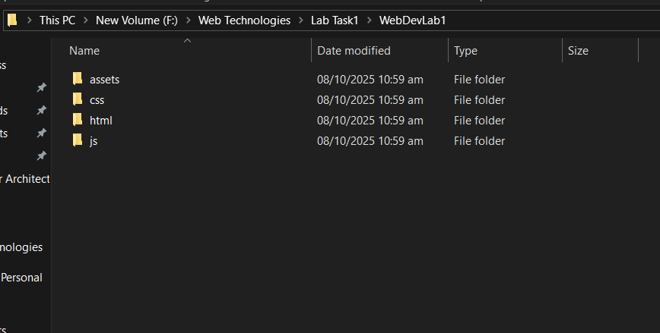

1. Initialize Git Repository
   * Open the folder in VS Code
   * Run:
   * git init

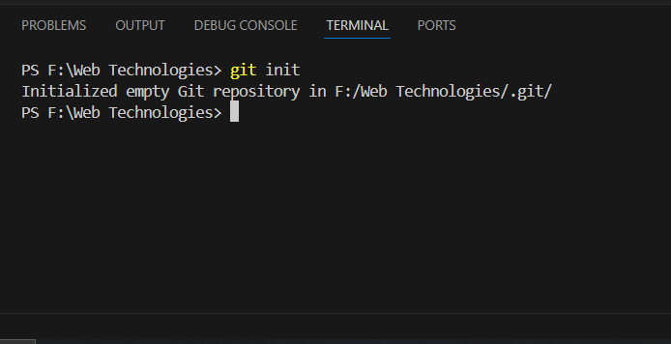

1. **Install Live Server**
   * In VS Code, go to Extensions → Search for “Live Server” → Click Install

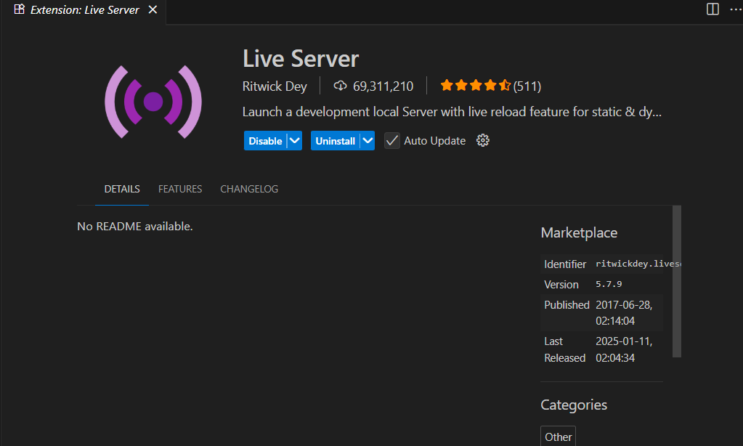

* + Right-click your index.html file → “Open with Live Server”

